Q1) Are the HTML tags and elements the same thing?

* HTML Tags and HTML Elements aren’t same things.

HTML tags are the building blocks of HTML. They define the opening and closing of an element whereas the elements are the structure which includes the opening tag, content and the closing tag.

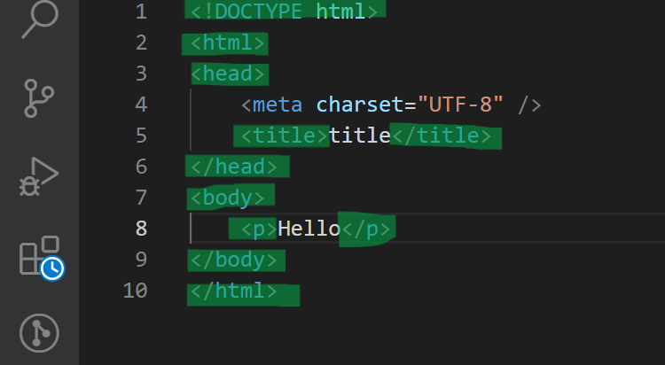

In this snippet of code, the Highlighted portions all highlights HTML Tags.

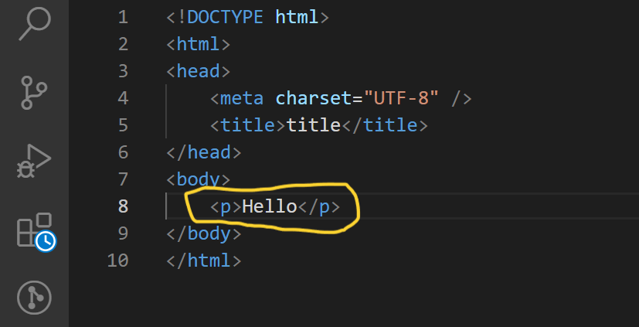

In this snippet of code, the highlighted code represents an HTML Element.

Q2) What are tags and attributes in HTML?

* Tags : Tags are the basic building blocks of HTML. Tags are defined by angular brackets. They are used to define & structure the content of the webpage.

The following is the structure of an HTML Tag.

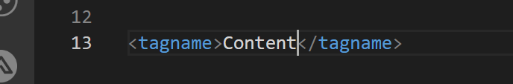

Example :-

<title>Hello World</title>

In this line of code, the <title> is an opening tag and </title> is a closing title.

* Attributes: Attributes are the components of HTML which provides additional characteristics and value to the element. It is applied to the opening of an element.

Structure of an Attribute :

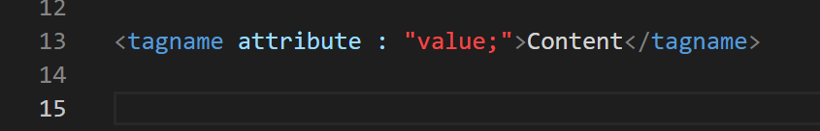

Tagname: It refers to the opening and closing tags.

Attribute: It refers to the characteristics of element.

Value: It refers to the value added to the attribute.

Example :

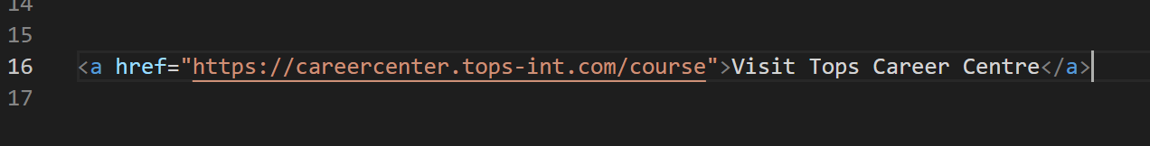

In this example,

<a> is the opening tag and </a> is a closing tag.

href is an attribute and the link is the value.

Q3)What are Void Elements in HTML?

* Void Elements : They are the elements which do not have an closing tag.

For example :

<br>,<hr>,<img>,<link>,<meta>,etc.

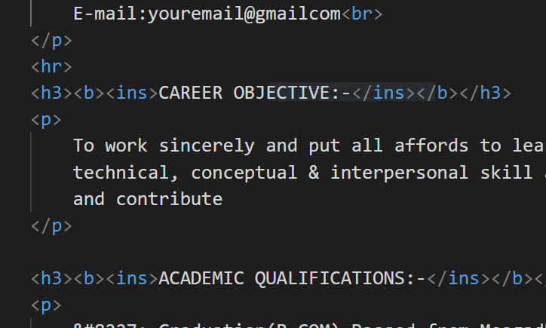

Q4) What are HTML Entities?

* HTML Entities are those reserved characters or symbols which are not present on the basic keyboard. Sometimes, we have to use those symbols in a webpage so we use HTML Entities.
* Syntax of HTML Entities :

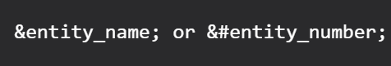

Example :

|  |  |  |
| --- | --- | --- |
| Symbol | Name | Syntax |
|  | Euro | &euro; |
|  | Yen | &yen; |
|  | Circle Bullet | &#8226; |
| & | Ampersand | &amp; |
|  | Triangle Bullet | &#8227; |
|  | Black Point Bullet | &#10687; |
|  | Pound | &pound; |

Q5) What are different types of lists in HTML?

* In HTML, we use lists to organize and structure items in a webpage.
* <li> tag means list items
* There are 3 types of Lists :

1. Ordered Lists
2. Unordered Lists
3. Definition Lists

* Ordered Lists : This type of list is used when the order is important. The list is marked by numbers or alphabets or another ordered markers.
* <ol></ol> tags means ordered list

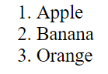 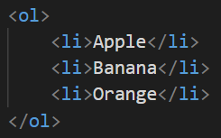

* Unordered Lists : This type of list is used when there is no need for an order to be kept among the list items. The bullet points, arrows, etc. are the unordered list markers.
* <ul></ul> means unordered lists

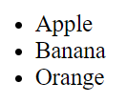 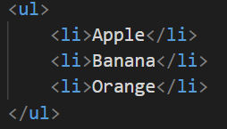

* Definition Lists : Defintion List is used to display information like that of in a dictionary.
* <dl></dl> represents Definition List
* <dt><dt> represents Data terms
* <dd></dd> represents Data Definition

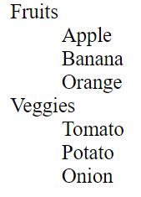 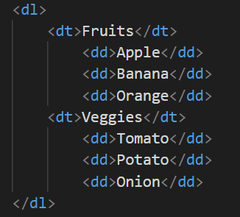

Q6) What is the ‘class’ attribute in HTML?

* In HTML, class attribute is used to apply one or more styles to an element.

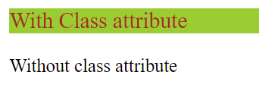

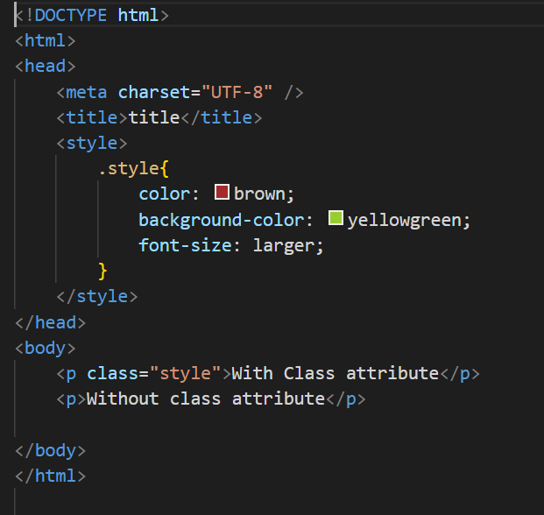

In this example, we have used class ‘style’ and applied to the first paragraph tag with having a larger font size as well as background color and font color whereas in the second paragraph tag we haven’t applied any styling.

Q7) What are the various formatting tags in HTML?

* The following table shows us various tags used for formatting in html

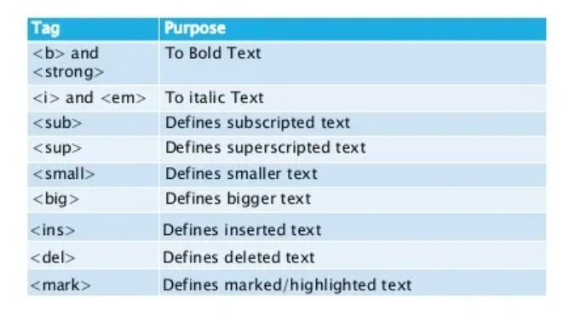

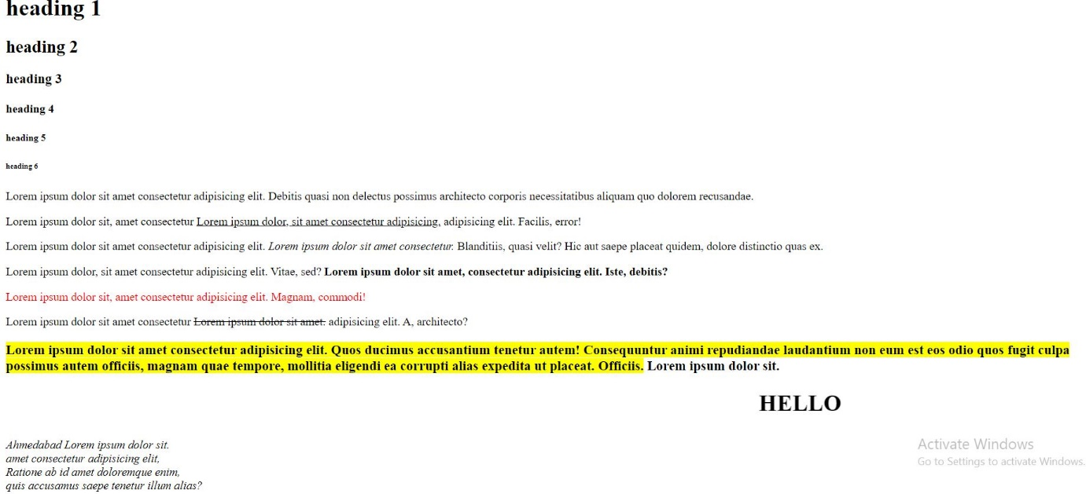

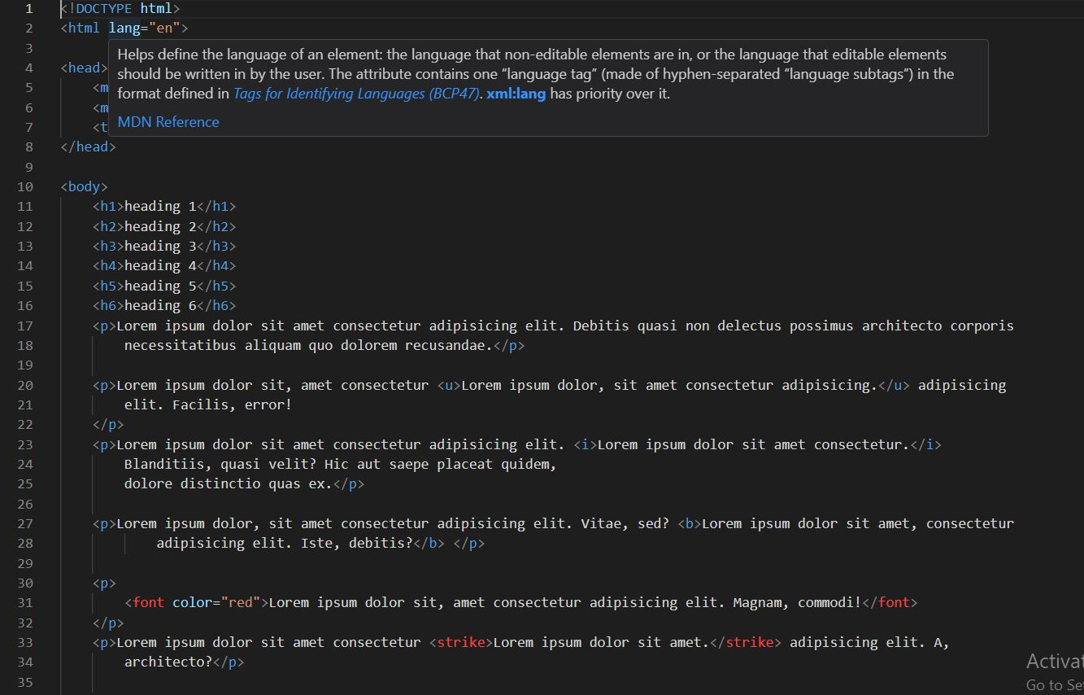

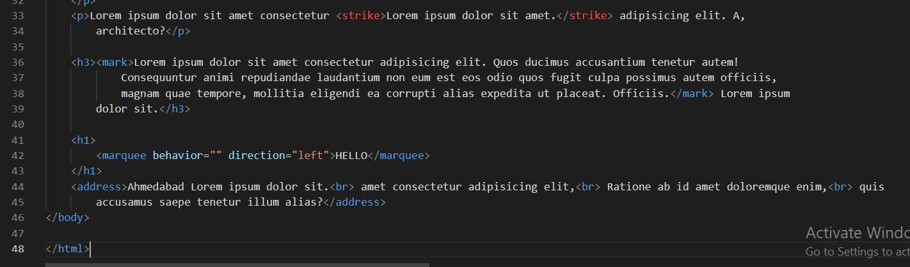

In this above HTML results, we have seen the use of tags such as bold, italic, marquee, underline, 6 types of headings, paragraph tag, strong tag, address tag, blockquote as well as mark tag.

Q8) How is Cell Padding different from Cell Spacing?

* **Cell Padding:** This table property sets the distance between the edge of the box-shaped element’s border and its content. It applies to the block-level boxes with borders but not those with none.
* **Cell Spacing:** Cell spacing is the space between cells in a table. This can be either vertical or horizontal, depending on your needs. Cell Spacing is the space between two cells in a table.
* **Difference between Cell Padding and Cell Spacing :**

|  |  |  |
| --- | --- | --- |
| Parameters | Cell Padding | Cell Spacing |
| Purpose | Cell Padding is the term used to describe the area between a table’s cell border and its content. | Cell Spacing is the gap between each neighbouring cell. |
| Number of cells | It just concern’s 1 cell | It is exposed to several cells at once. |
| Default value | 1 | 2 |
| Process of creation | It may be made using the <table cellpadding =”10”> </table> tag | It may be made using the <table cellspacing =”10”></table> tag |
| Effectiveness | It is more effective than cell spacing | It is less effective than cell padding. |

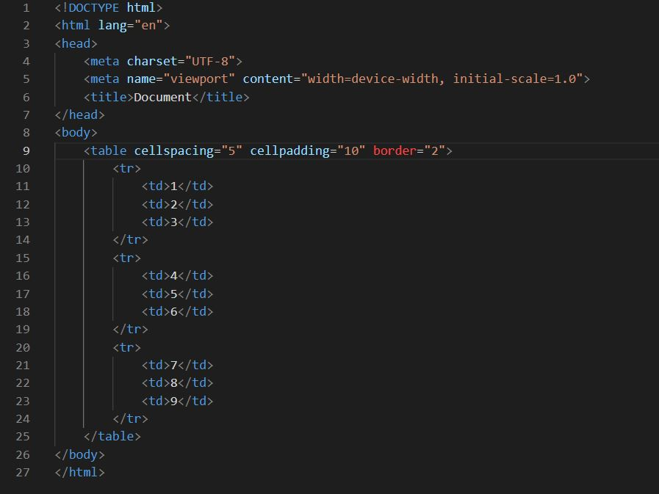

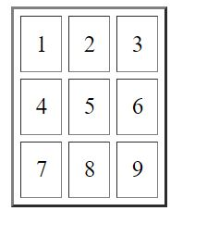

Q9) How can we club two or more rows or columns into a single row or column in an HTML table?

* We can club or group two or more rows in a table using a property of table in HTML called **‘colspan’.**
* We can club two or more columns in a table using a property of table in HTML called **‘rowspan’.**

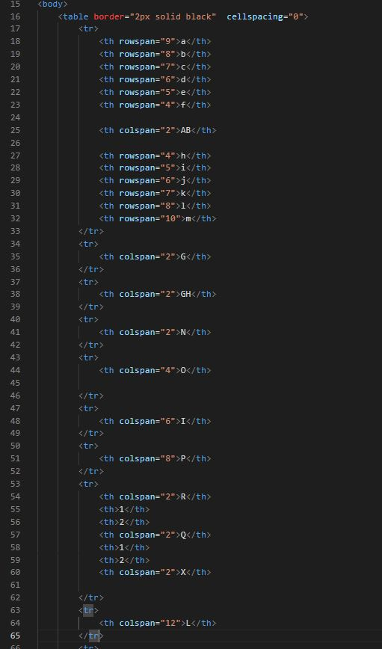

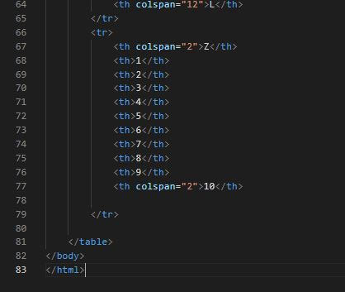

Output :

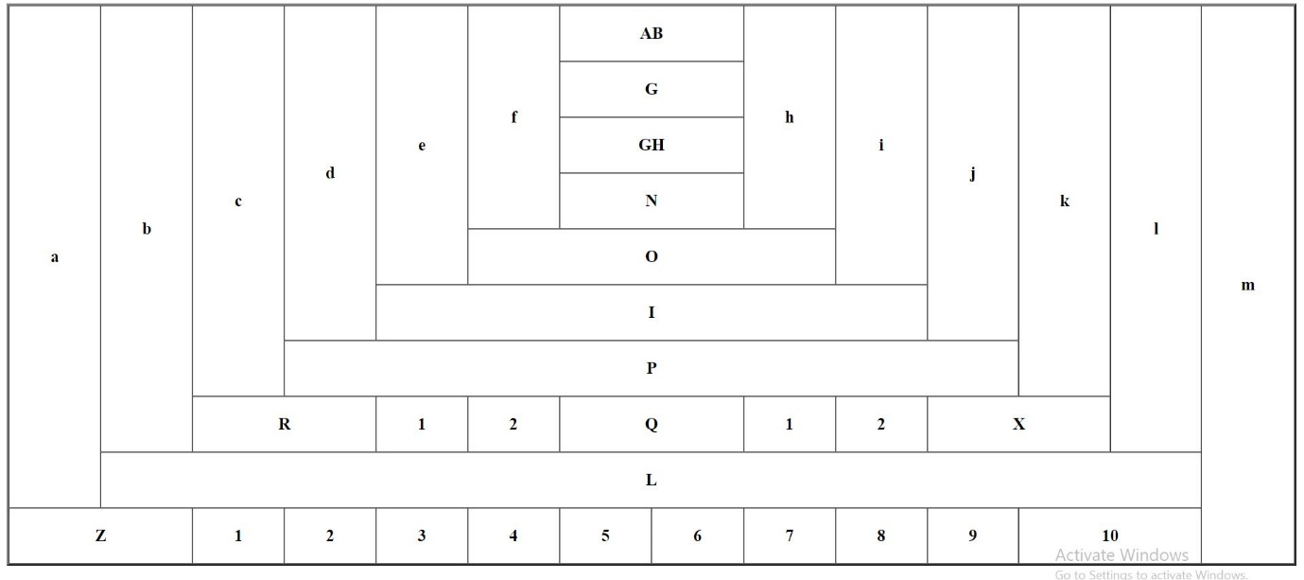

Q10) How to create Hyperlink in HTML?

* Hyper link in html can be created using <a> tag. The syntax for hyperlink is:

<a href = “index.html”>Home Page</a>

* Links are used everywhere in webpages whether for connecting one webpage to another webpage or any other tasks.

Q11) What is the use of iframe tag?

* An HTML Iframe tag is used to display a webpage within a webpage.
* It creates diiferent section in a webpage where another webpage can be displayed
* 

Q12) What is the use of span tag>Explain with example?

* A <span> tag is an inline container which is used to mark up a part of text,paragraph or a document.
* We can easily style that part of the text with the help of <span> tag.
* The <span> tag is much like <div> element, but <div> is an block element while <span> is an inline element.

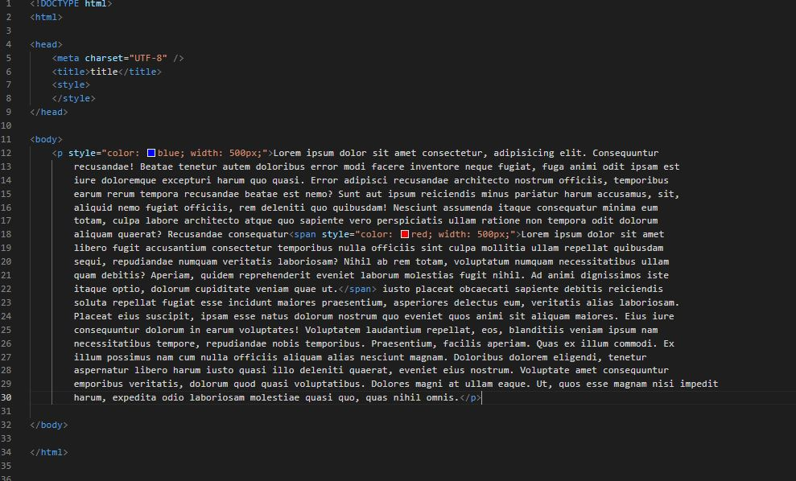

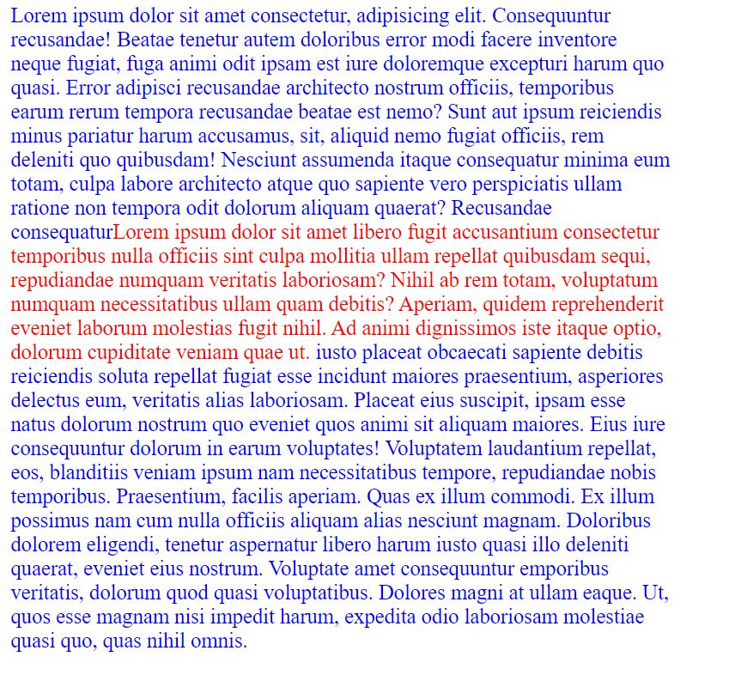

Q13) How to insert a picture into the background image of a webpage?

* We can use <img> tag to insert an image in the background of a webpage by adjusting its height and width.
* 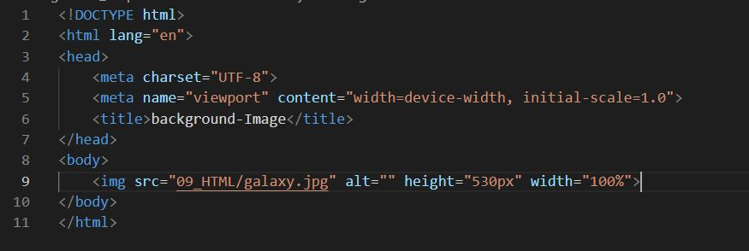



Q14) How are active links different from normal links?

* A normal link is just a line of code that contains a pointer to another resource. An active link is that line of code in action, opening that other resource.



 It is a normal link

Active Links are those links which are already active in your computer.

Q15)What is SVG?

* SVG stands for Scalabe Vector Graphics.
* SVG defines the graphics in XML format.
* With the help of SVG we can create different shapes in web.
* We can create circle, square, rectangle, triangle as well as different types of polygon in HTML.
* SVG images are scalable as well as zoom-able.
* They do not lose any quality upon being zoomed in or out.
* SVG files are pure XML Files.

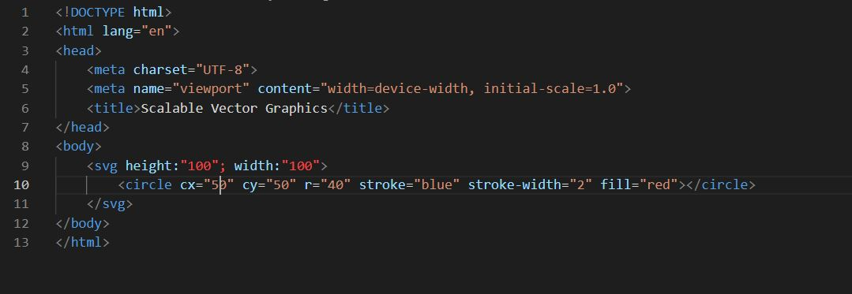

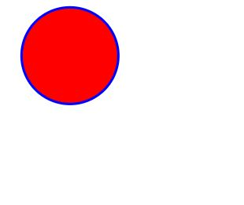

In the first image, we could see the code for plotting a circle in webpage using SVG, while the second code shows us its output.

Q16) What are the different types of tags to separate sections of text?

* Different tags to separate sections of text are:

|  |  |
| --- | --- |
| Tags | Name of Tag |
| <p></p> | Paragraph |
| <i></i> | Italic |
| <br> | Break Line |
| <section></section> | Section tag |
| <blockquote></blockquote> | BlockQuote tag |

Q17) What is difference between HTML and XHTML?

|  |  |  |
| --- | --- | --- |
| Property | HTML | XHTML |
| Fullform | Hyper text markup language | Extensible hyper text markup language |
| Extension | .html | .xml, .xhtml |
| Extended form | SGML | XML,HTML |
| Function | Webpages are written in HTML | Develop applications and webpages. |
| Nature | Less Strict | More Strict |
| Whitespace Handling | Extra lines does not matter | Extra lines does Matters |
| Media and MIME Types | Limited flexibility in specifying media | More options available for specifying media |

Q18) What are logical and physical tags in HTML?

* Logical tags: These tag allows to render that information for the browsers in most applicable way.
* Physical Tags: Physical tags describe the appearance or presentation of content.
  + Tags: <b>, <i>, <h1> to <h6>, <u>, <sub>, <sup>, <strike>, etc.

Q19) What is the difference between the ‘id’ attribute and the ‘class’ attribute of HTML elements? With Example.

* The id attribute is a unique identifier that is used to specify the document. It is used by CSS and JavaScript to perform a certain task for a **unique** element. In CSS, the id attribute is written using the # symbol followed by the id.
* While we can use a single ID multiple times in HTML but we cannot use more than once in JavaScript as it would result in error.
* Syntax :

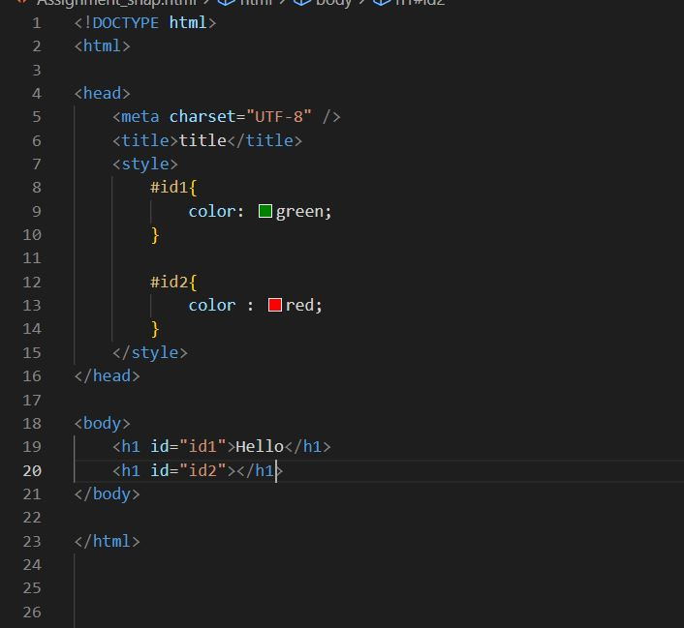

* Output:

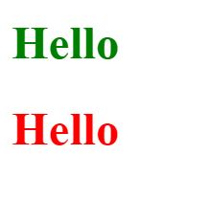

* HTML Class Attribute: The class attribute is used to specify one or more class name for an a HTML element. The class attribute can be used on any element in Html.
* The class attribute in CSS can club many properties which could be shared by many elements in HTML
* The class name in CSS is written using (.) symbol.
* Syntax :

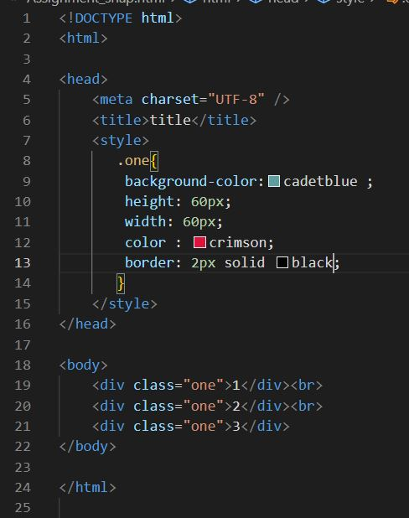

* Output

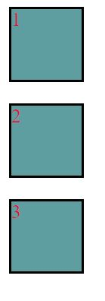

Q20) What is the difference between a block-level element and an inline element?



|  |  |  |
| --- | --- | --- |
| Parameters | Inline Element | Block Element |
| Margins | Only left and right margins have effect on inline elements | All types of margins have effect on block elements. |
| Height and Width | Height and Width are not considered for inline elements | Heights and Widths are key properties of block elements. |
| Flow | Inline elements continue in the same line | Block elements force a new line for every elements. |
| Scope | Inline elements cover only the area which is required for the content in holds | Block elements cover the whole horizontal line in which they are used. |
| New Line | Not required | Yes |
| Purpose | Inline elements are used generally to give inline styles and effects | Block elements live div tags are extensively used for defining the layout of the webpage. |
| Example | ‘<span>’,’<a>’,’<img>’,  ’<button>’,etc. | ‘<div>’,’<h1>’,’<.p>’,etc. |

* **HTML TASK**
* Code :

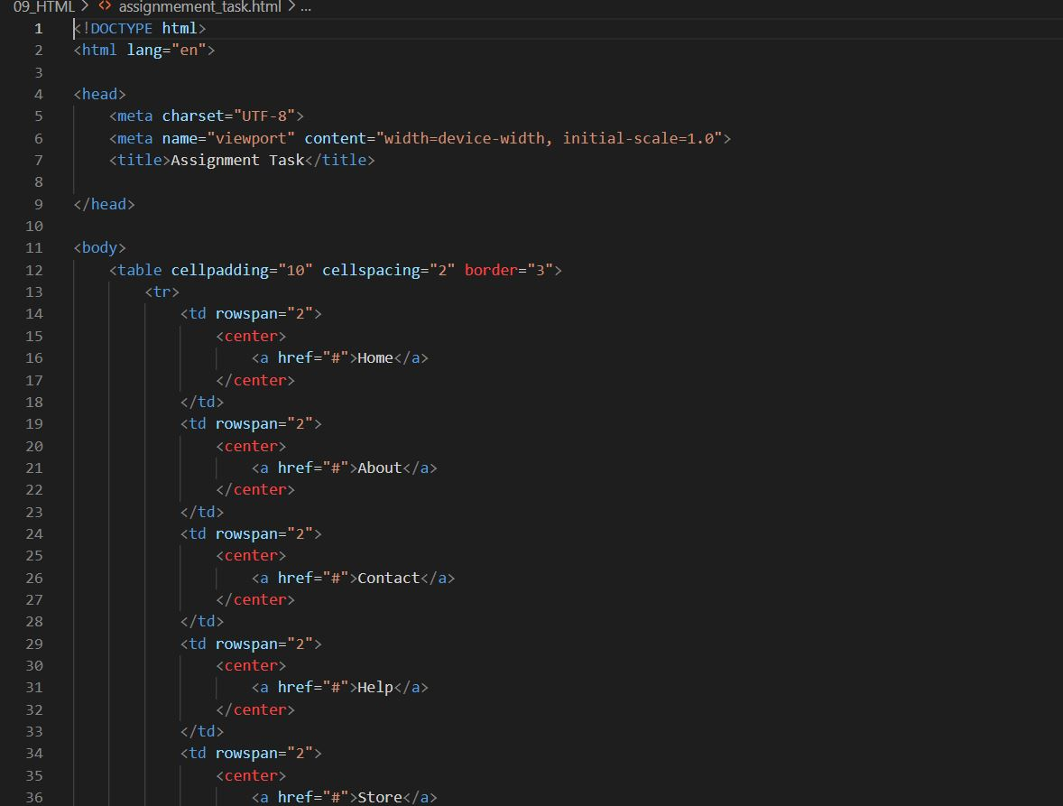

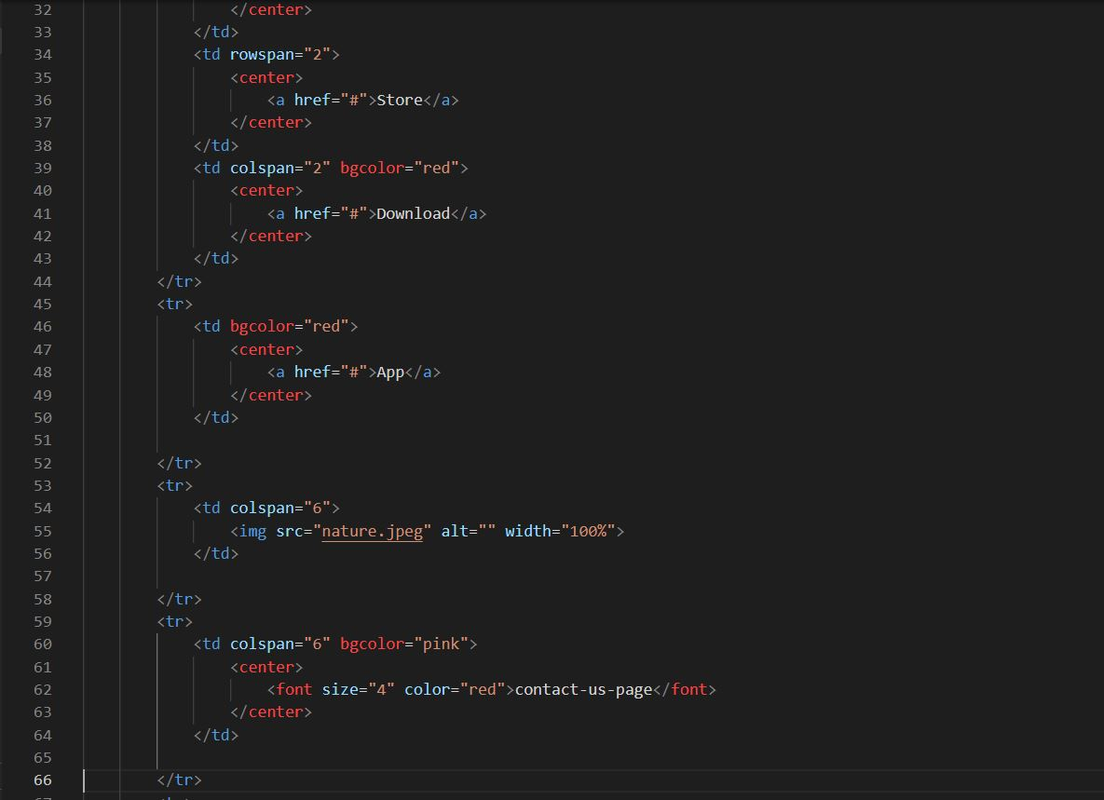

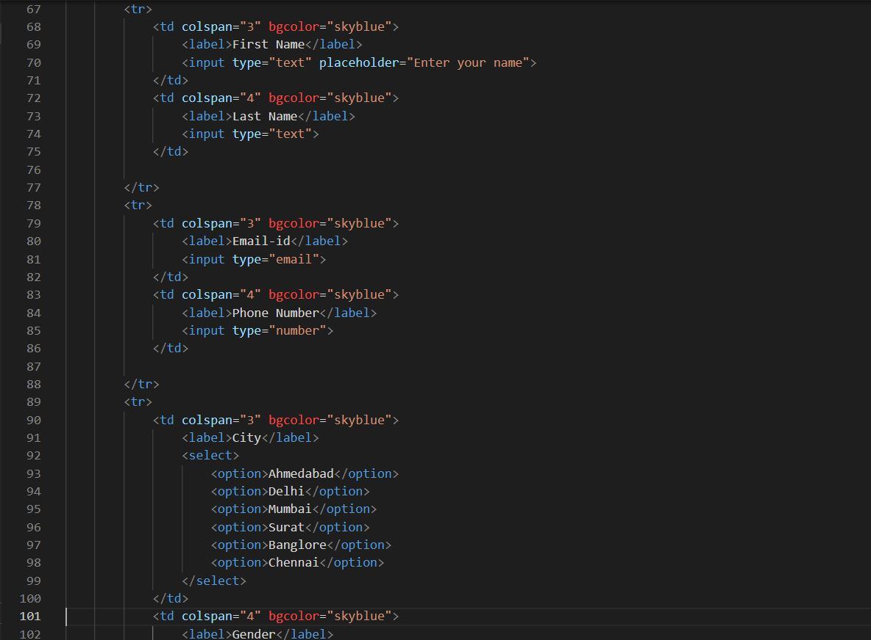

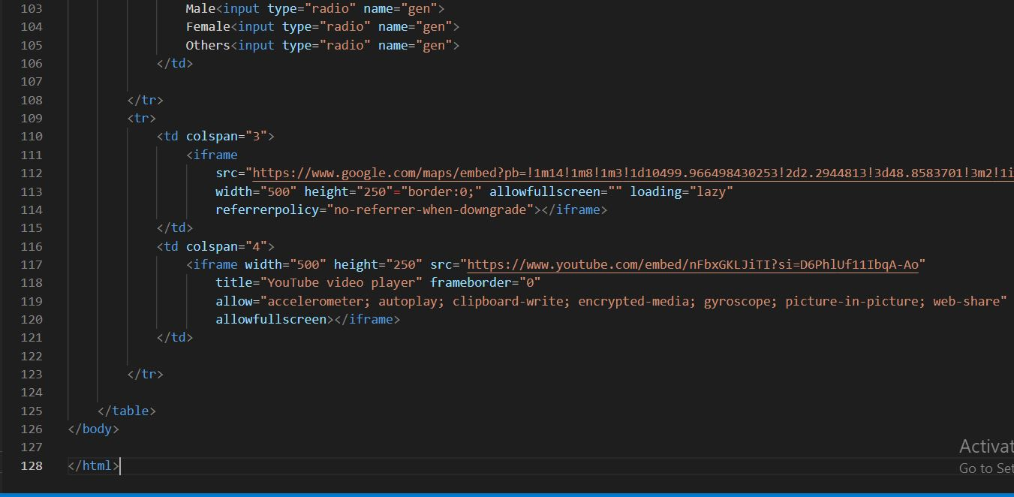

* Output :

